Sprint #1 UI Prototypes

**US-40**: As a public user, I want to be able to create a unique profile by providing a profile picture, user name, contact email, and phone number.

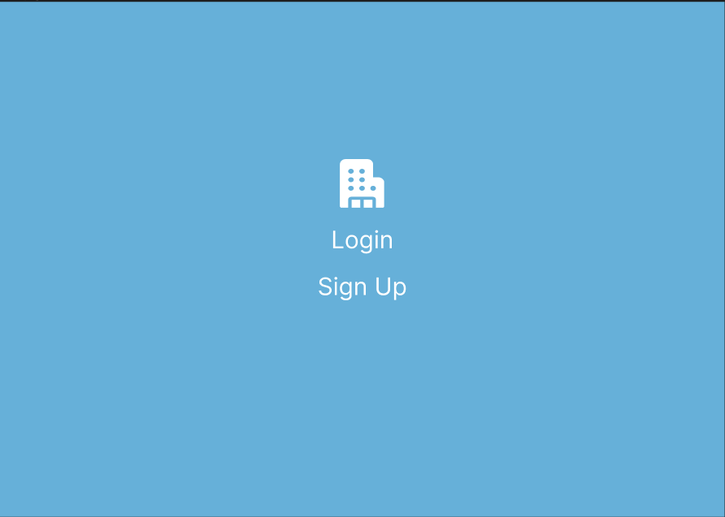

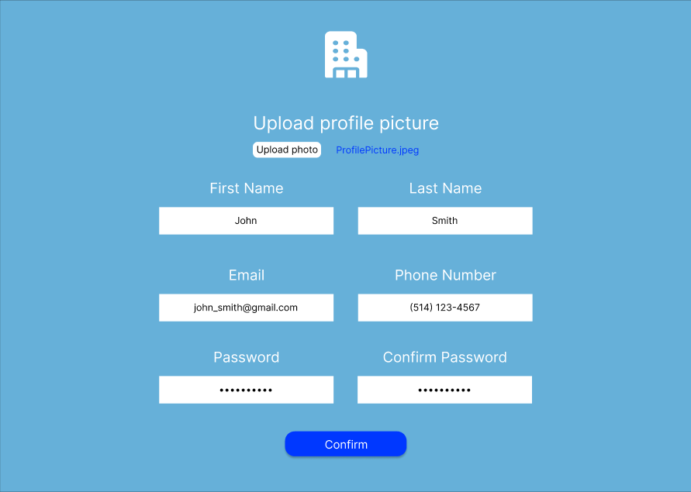

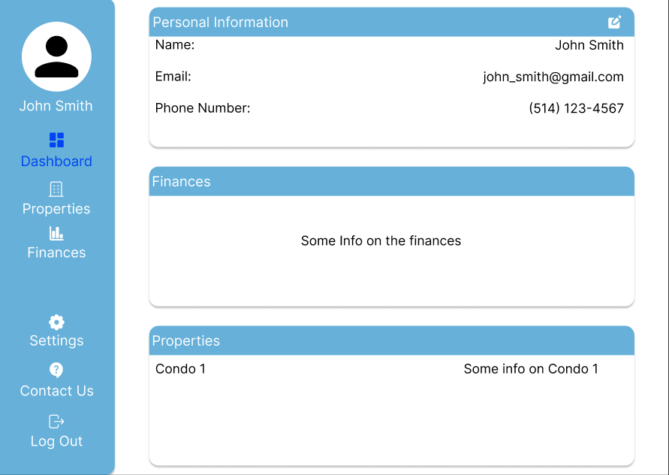

Steps:

1. The user accesses the website and clicks on Sign Up.
2. The user uploads their profile picture, first name, last name, email and phone number.
3. The user enters their password and enters a second time to confirm.
4. The user clicks on the Confirm button
5. The user is redirected to the Dashboard page

**US-42**: As a condo owner, I want to have a dashboard that displays general information about my properties, including personal profile, condo information, and financial status.



Dashboard page

Steps:

1. After a successful login or sign up, the user will be redirected to this dashboard page.
2. The user will be able to see their personal information, properties and condo information and their financial information.

**US-45**: As a condo management company, I want to be able to create profiles for properties under my management, providing essential information like property name, unit count, parking count, locker count, and address.

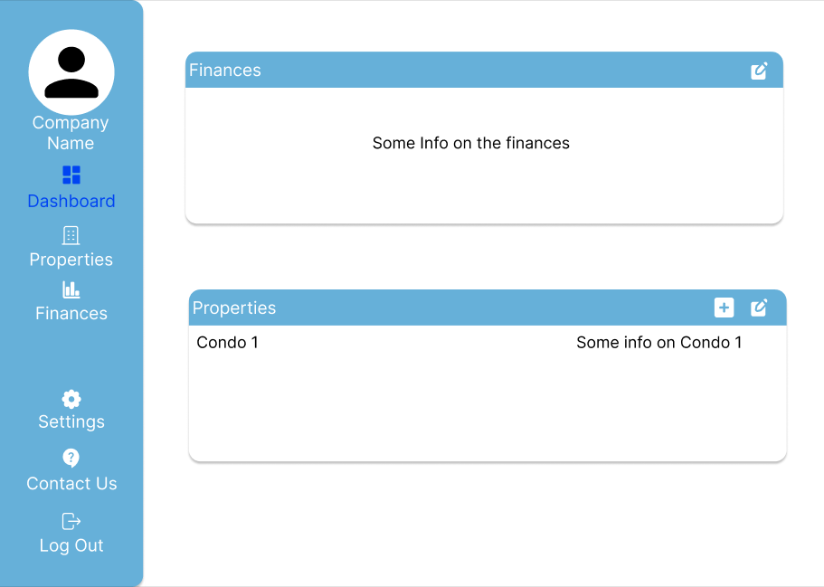

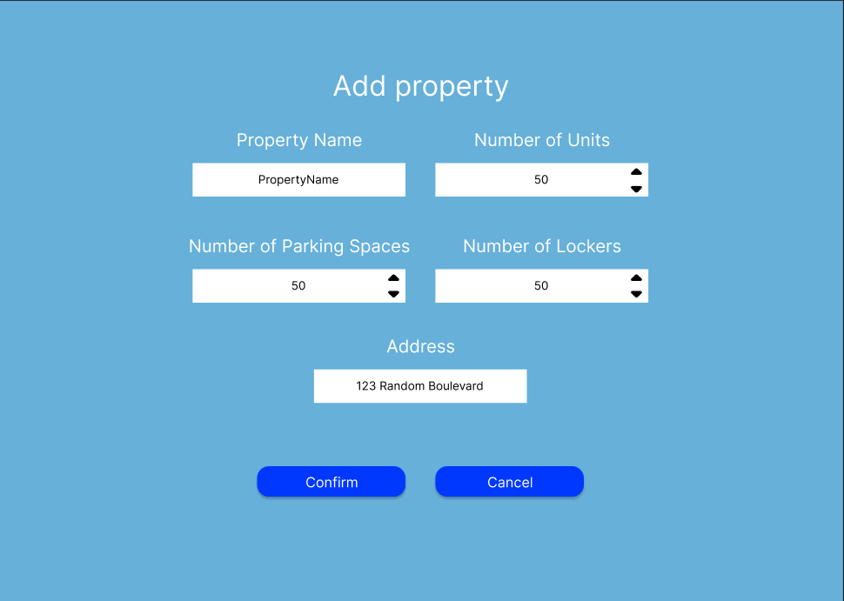

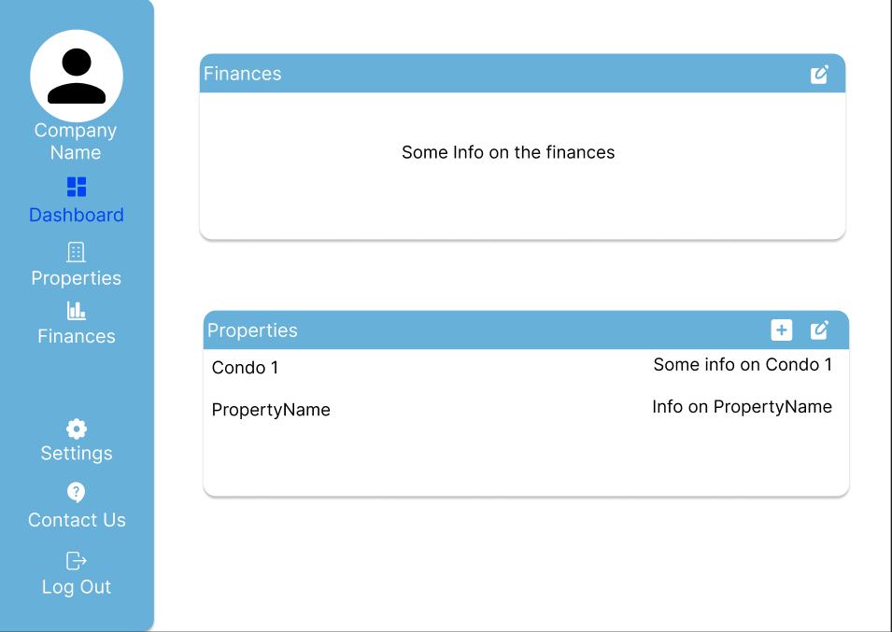

Steps:

1. On the condo management company dashboard, the user clicks on the add icon in the Properties box.
2. The user enters the name of the property, the number of units, parking spaces and lockers and the address of the new property.
3. The user clicks on Confirm.
4. The user is redirected to an updated Dashboard page with the new property and its info added in the Properties box.

**US-46**: As a condo management company, I want to upload condo files for each property, accessible to all condo owners, including declarations, annual budgets, and board meeting minutes.



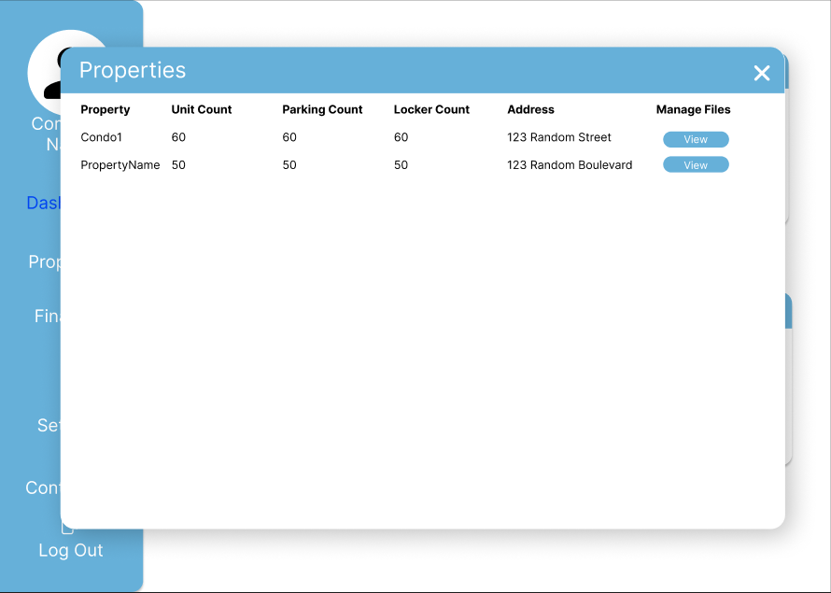

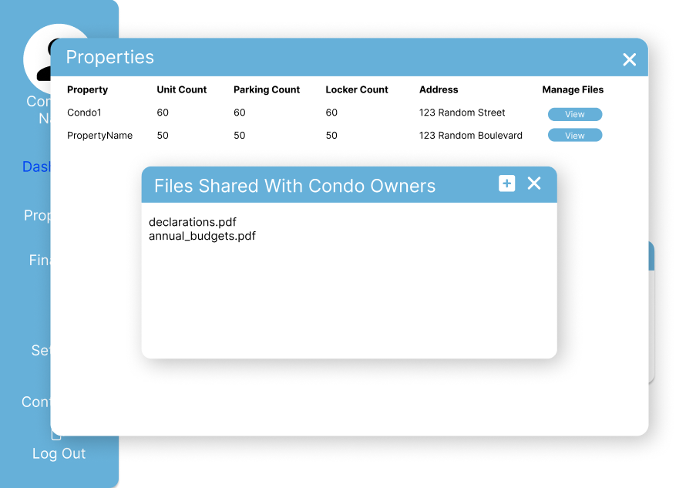

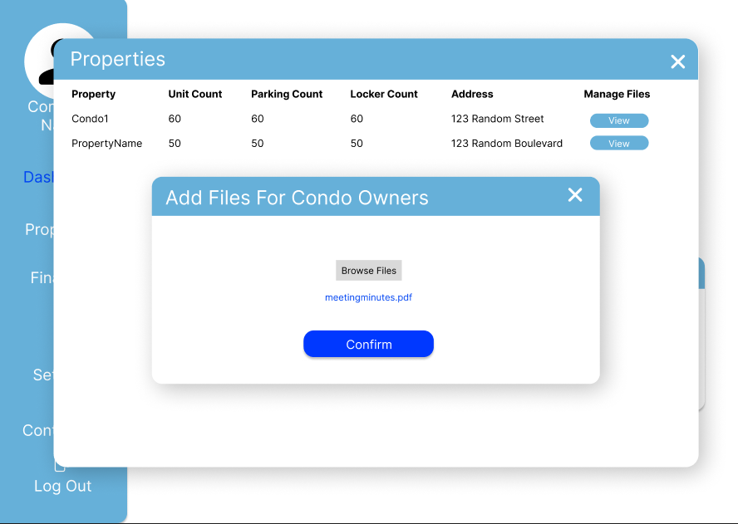

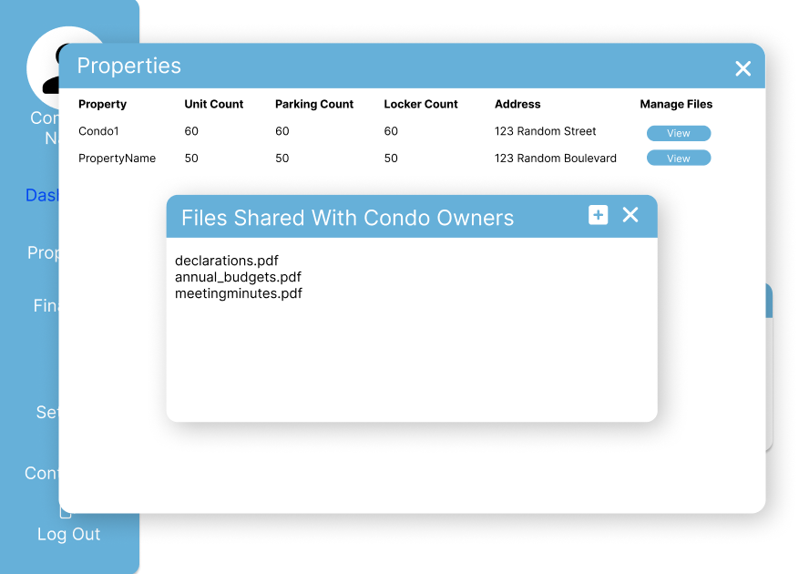

Steps:

1. From the dashboard, the user clicks on the edit properties button in the properties box.
2. The user clicks on the view button for the corresponding property for which they want to manage its files.
3. The user clicks on the add files button to upload new files.
4. The user browses files to upload the ones that they want to share with the condo owners.
5. The user clicks on Confirm.
6. The user is redirected to the Files Shared With Condo Owners window with the newly uploaded file in the view.

**US-47**: As a condo management company, I want to enter detailed information for each condo unit, parking spot, and locker, including unit size, owner information, and associated condo fees.



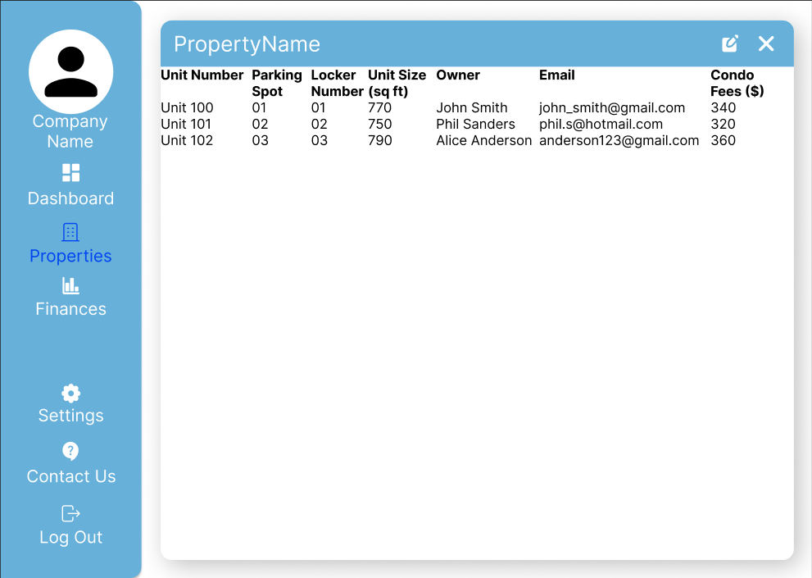

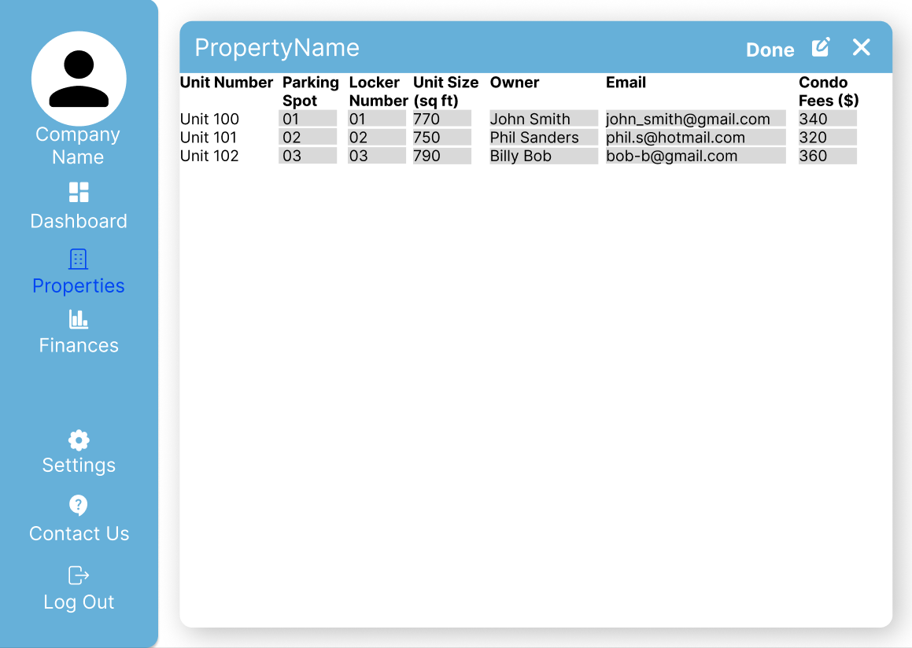

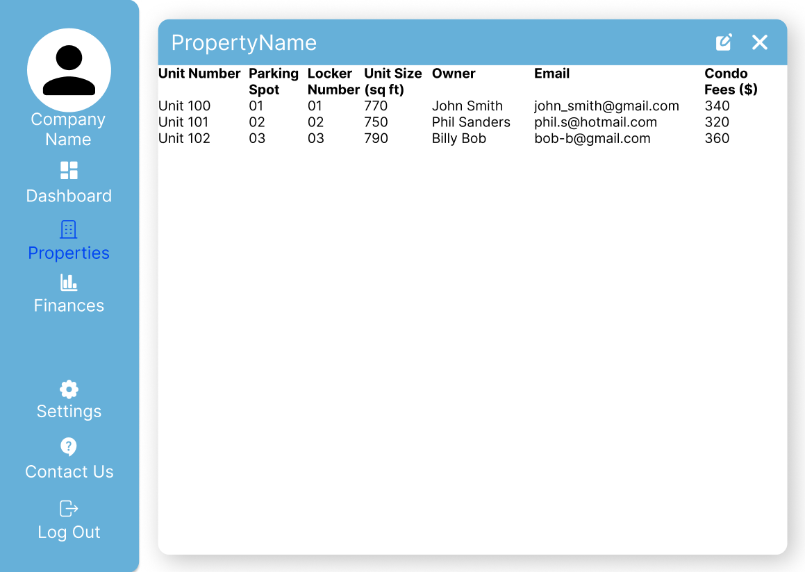

Steps:

1. The user clicks on the name of the condo.
2. The user is redirected to the Properties page for the specific condo they clicked on.
3. The user clicks on the edit button.
4. The user edits the condo unit they want.
5. The user clicks on the Done button.
6. The user then sees the edited Property page of the condo they viewed.